AI Use Declaration Form
Course: Introduction to Artificial Intelligence
Lab Title: Lab 4: LLMs and Prompt Engineering for Decision Support
Student Name: Mariam Goge Kessa
Student ID: 30682027
GitHub Repository Link: https://github.com/gogekessa-nigerienne/lab-4-llm-decision-support.git

Date Submitted: 20/6/2026

1. AI Use Summary
Question | Student Response
Did you use any AI tool for this lab? | yes
Estimated percentage of the work influenced by AI | 25 %
Did you attach evidence of AI use where applicable? | yes

2. Details of AI Use
Complete the table below for each AI tool used. Add more rows where necessary.
Name of AI Tool Used | Purpose for Using the Tool | Prompt or Instruction Given to the Tool | Part(s) of the Work Influenced by the Tool | How I Verified, Edited, or Improved the AI Output
Copilot | Seeking help in setting this up | how do I Pick one API provider with a free tier (Groq is recommended, but Gemini or Hugging Face also work) in google colab | Part 0: Repository and API-key setup | I followed the explanation and figured out what to do next
 | Error explanation and debugging | What is this error about:--------------------------------------------------------------------------- SecretNotFoundError Traceback (most recent call last) /tmp/ipykernel_1179/1436714469.py in <cell line: 0>() 12 # --- Google Colab (Secrets panel) --- 13 from google.colab import userdata ---> 14 API_KEY = userdata.get("GROQ_API_KEY") 15 16 # TODO: set API_KEY using ONE of the methods above.  /usr/local/lib/python3.12/dist-packages/google/colab/userdata.py in get(key) 66 raise TimeoutException(key) 67 if not resp.get('exists', False): ---> 68 raise SecretNotFoundError(key) 69 if not resp.get('access', False): 70 raise NotebookAccessError(key)  SecretNotFoundError: Secret GROQ_API_KEY does not exist. | Part 1.1 — Your first API call
 |  |  | Part 3.1 — Component 1: Summarization

3. Attachment of AI Output Evidence
Where required, attach evidence of AI use. Tick all that apply. Add more rows where necessary.

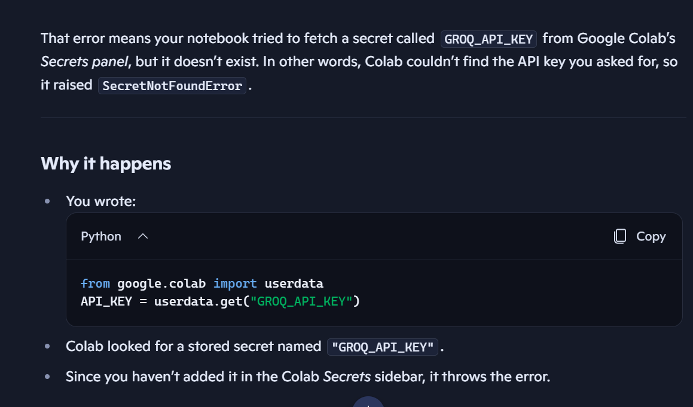
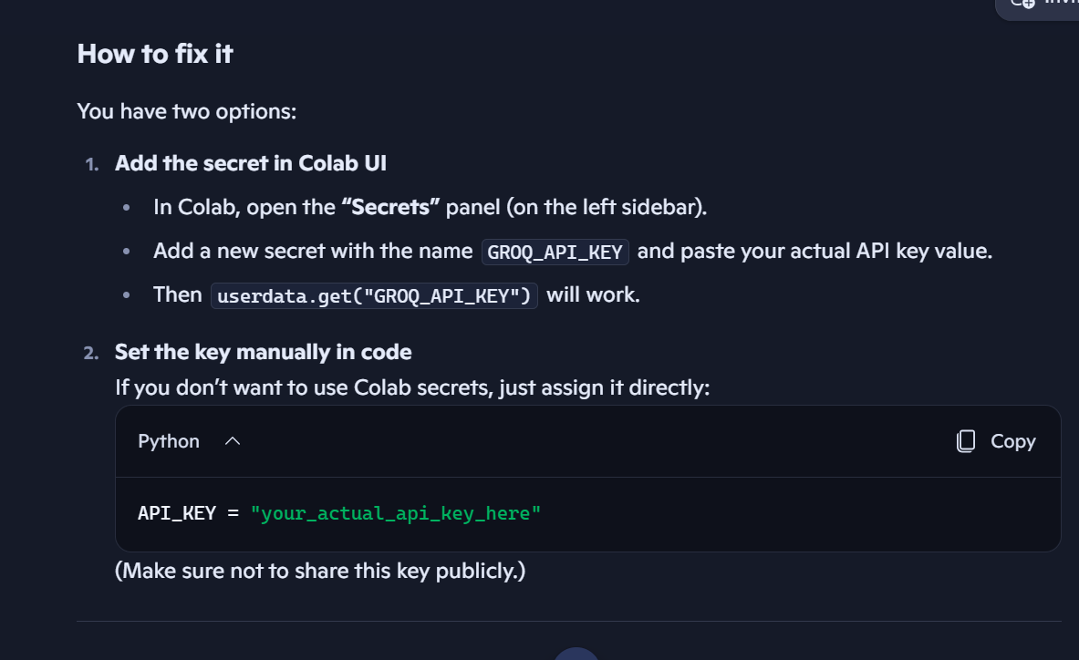
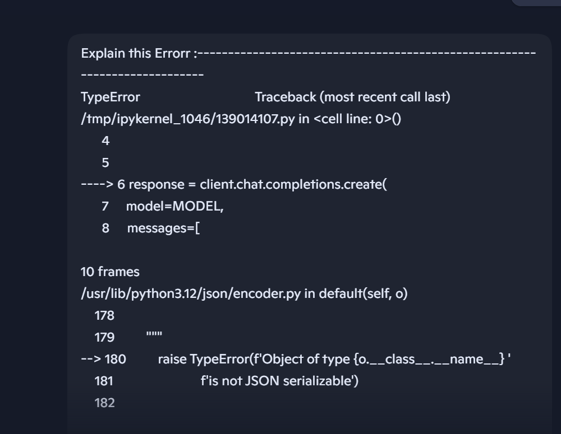
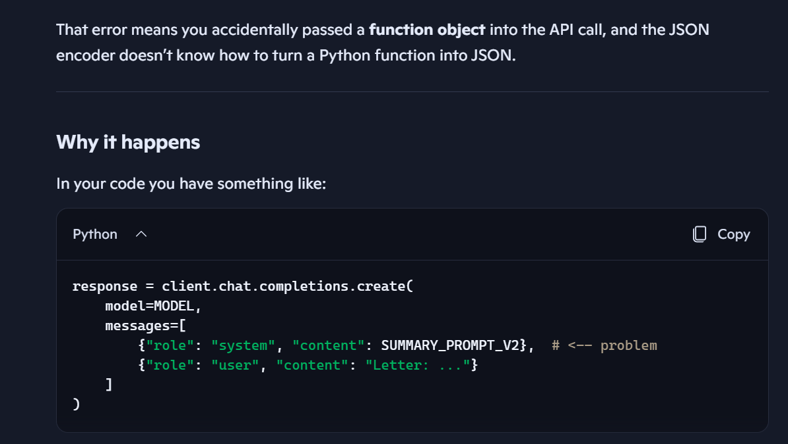
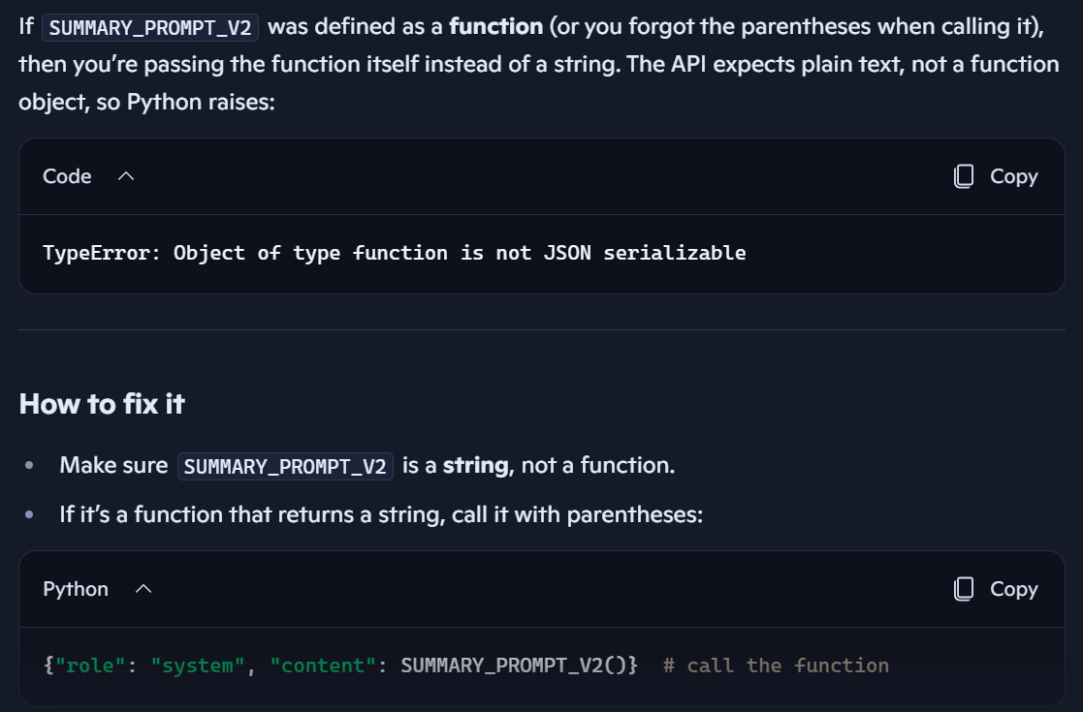
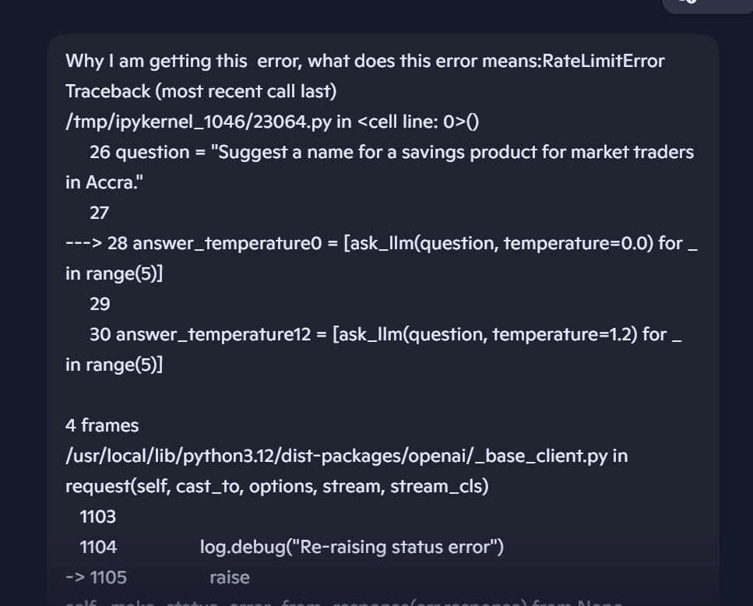
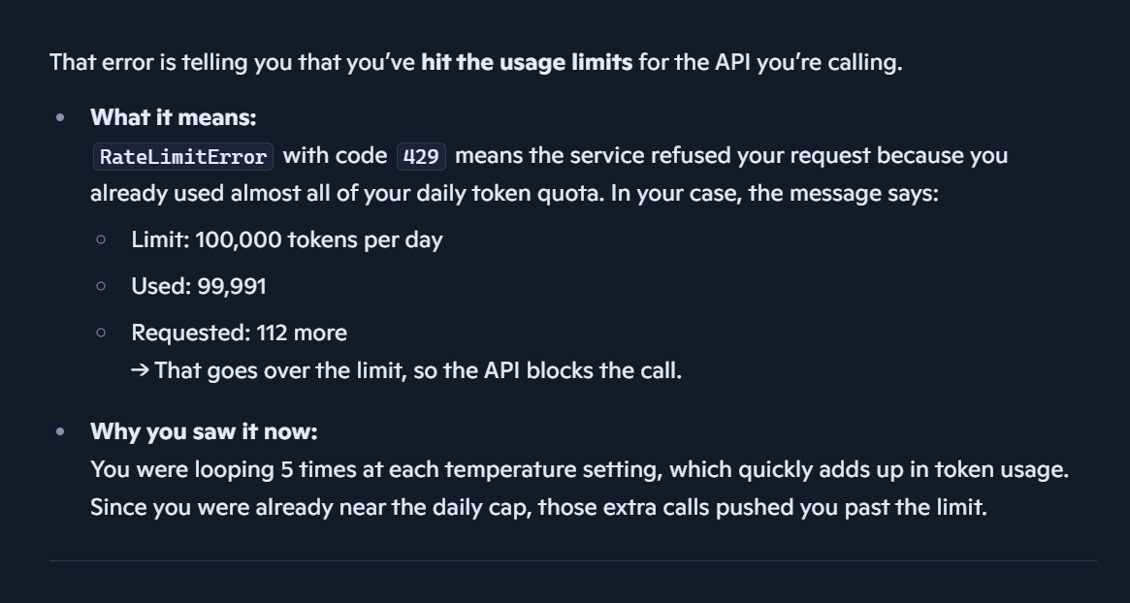
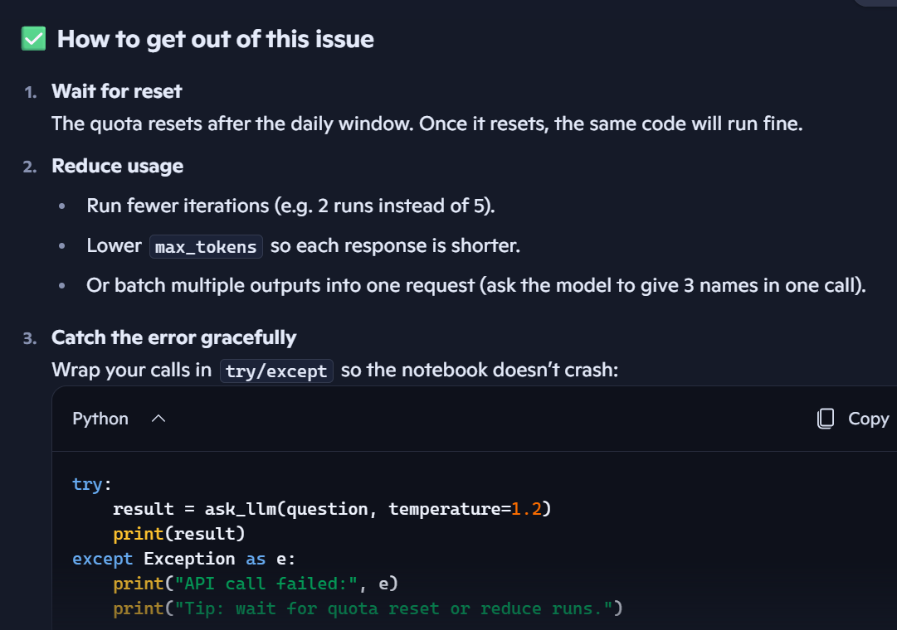

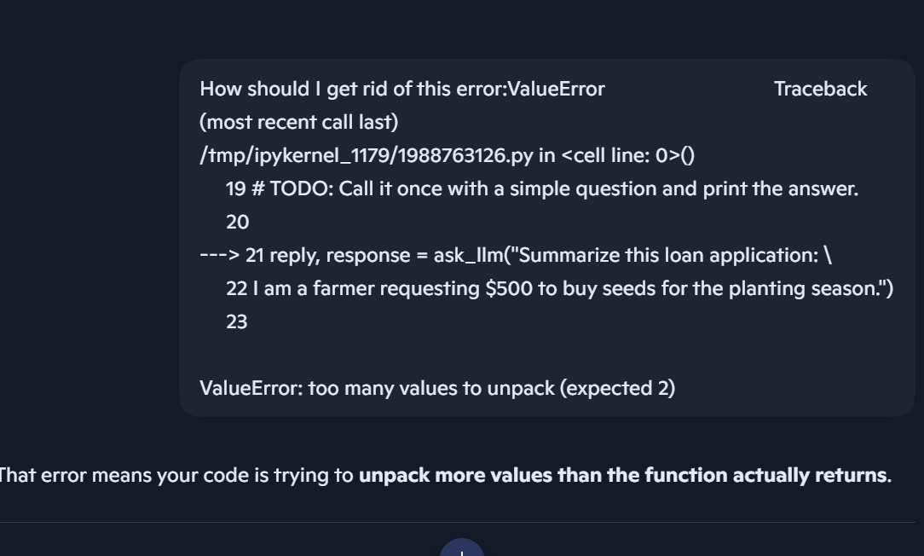
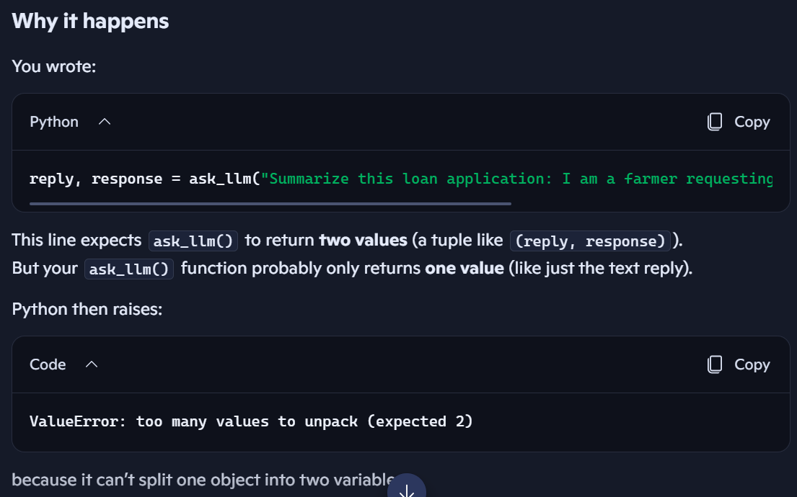
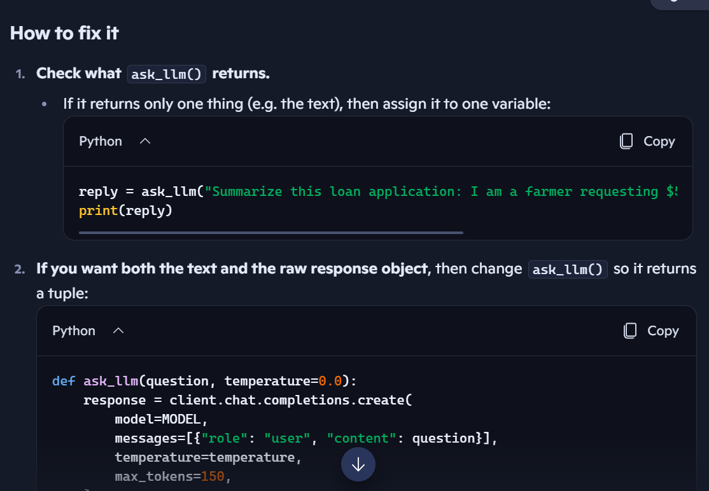

Evidence Type | Attached? (Yes, No, N/A) | File Name
AI-generated draft | yes | Screenshot
Prompt history | yes | Screenshot
Screenshot of AI interaction | yes | Screenshot
Exported AI conversation | yes | Screenshot
AI-generated code snippet | yes | Screenshot
Revised version showing student input |  | Screenshot

4. Student Declaration
I declare that:
Declaration Statement | Response (Yes/No)
The submitted work is my own work. | Not fully but the larger part of it.
Any use of AI tools has been clearly declared in this form. | yes
The prompts, instructions, and AI-generated outputs have been disclosed where applicable. | yes
I reviewed, tested, edited, and improved any AI-generated content before submission. | yes
My AI usage does not exceed 25% of the entire work. | yes
I understand that undeclared or excessive AI use may be treated as academic misconduct. | yes

Student Signature: MGK
Date: 13/08/2026

